HM200 Checkpoints

**Version 2 – Wintringham checkpoint replaced by SETTRINGTON BEACON**

Yellow blobs are the check points

Arrows are the direction in which the runners will be running/walking/crawling

# RACE START Queen Victoria Docks V/Hall  110 287  Postcode – HU9 ITL  Start -0800

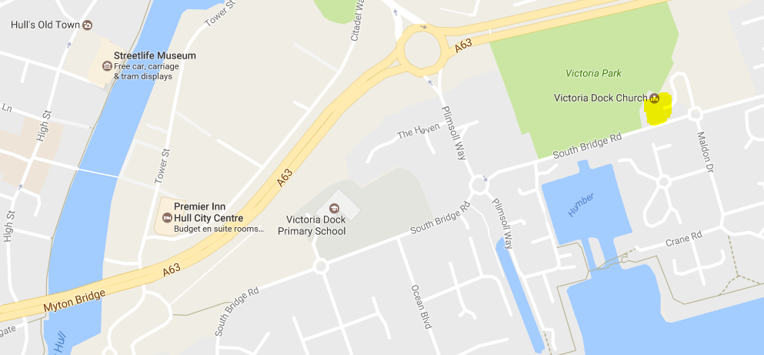

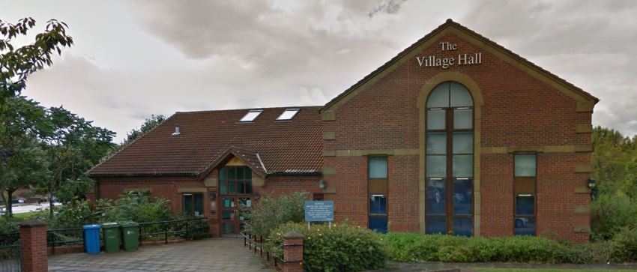

# Wolds Way Start 028 253 HU13 OHE  Humber Bridge Carpark, Cliff Rd

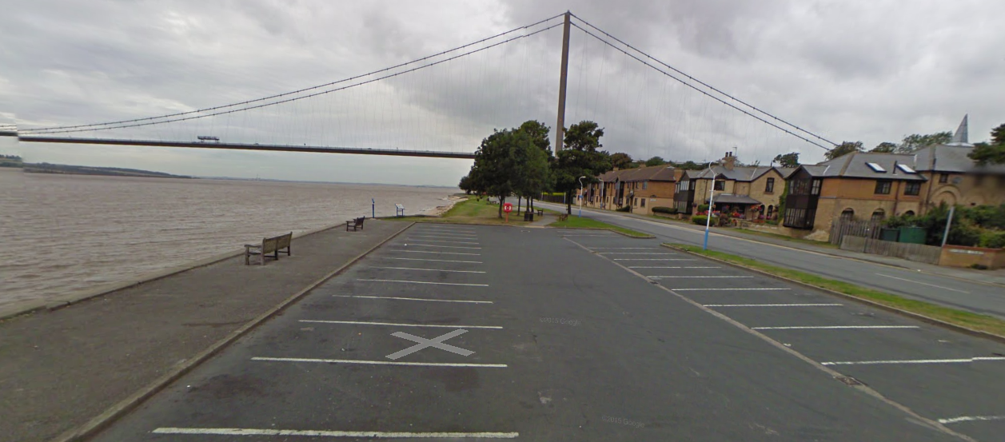

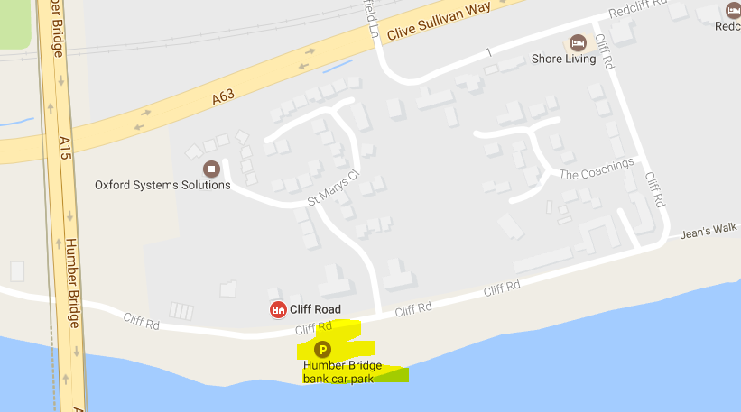

# 2. Brantingham (nr Church) 943 301  HU15 1QN (17 miles) **COMPULSORY**

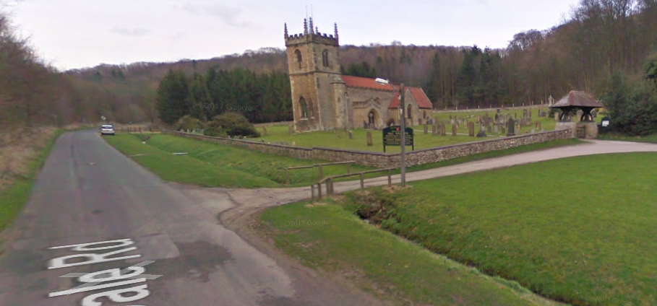

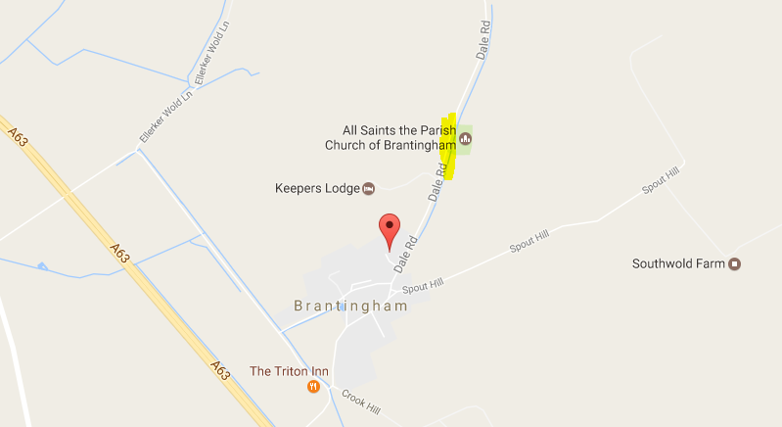

# 3. Arras Wold (nr 1079) 925 412  Postcode  – YO43 4RL   10 miles (27)

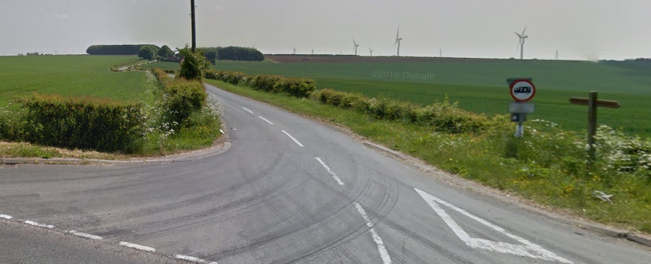

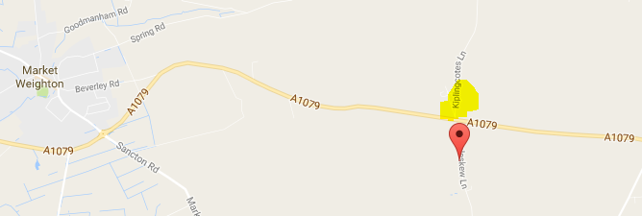

# MARKET WEIGHTON, Hall Road  877 4192  YO43 3BA  (30.5 miles)

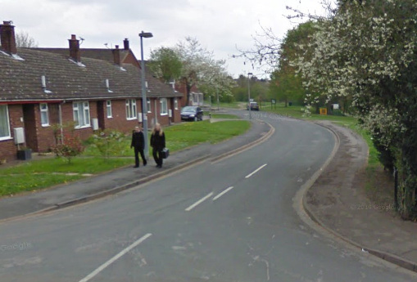

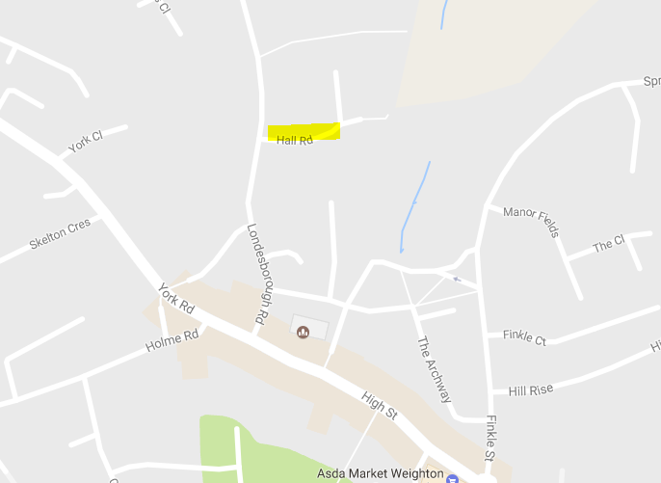

# 4. Millington V/Hall  831 519  YO42 1TX  (40 miles) **COMPULSORY**

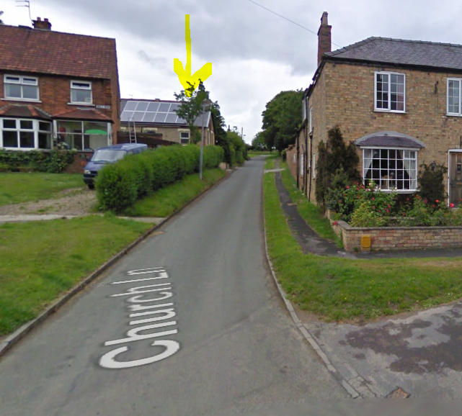

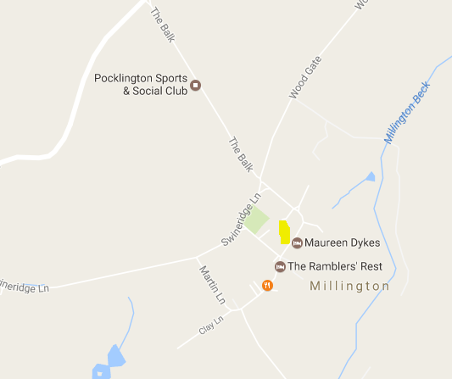

# FRIDAYTHORPE Back Street  873 592  YO25 9RW (48 miles)

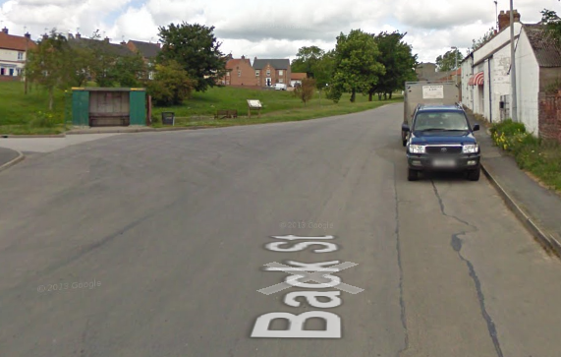

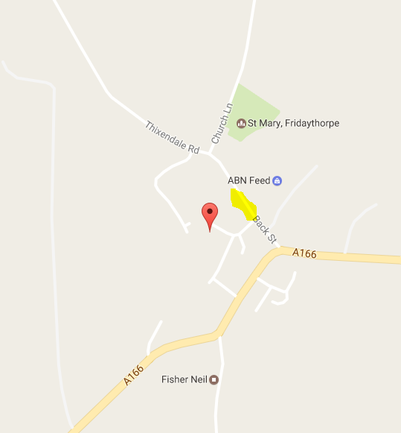

# 5. Wharram Percy (Carpark) 866 644  (57 miles) **COMPULSORY**

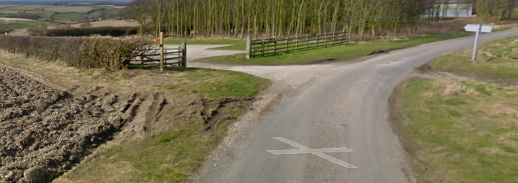

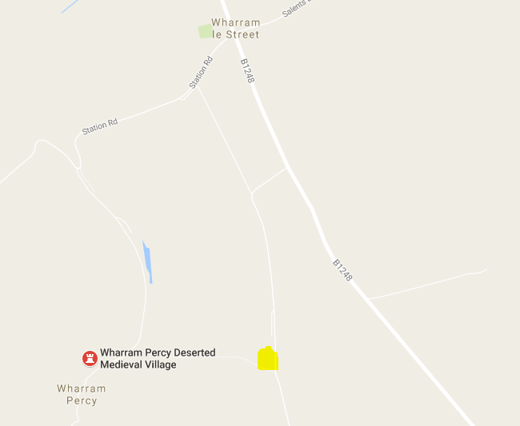

# SETTRINGTON BEACON 866 705  YO17 8BQ  (62 miles)

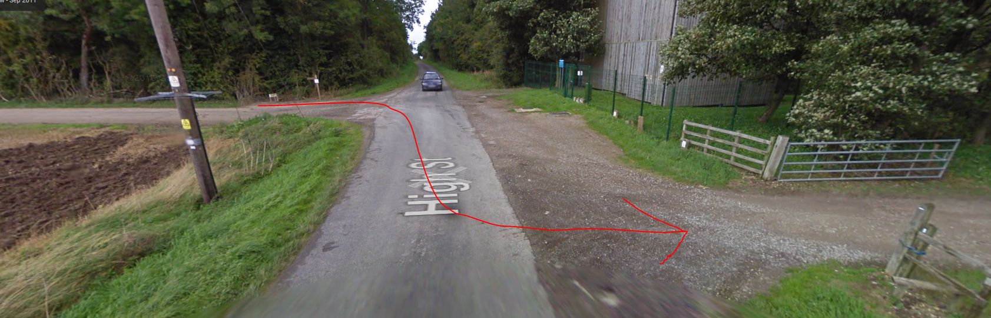

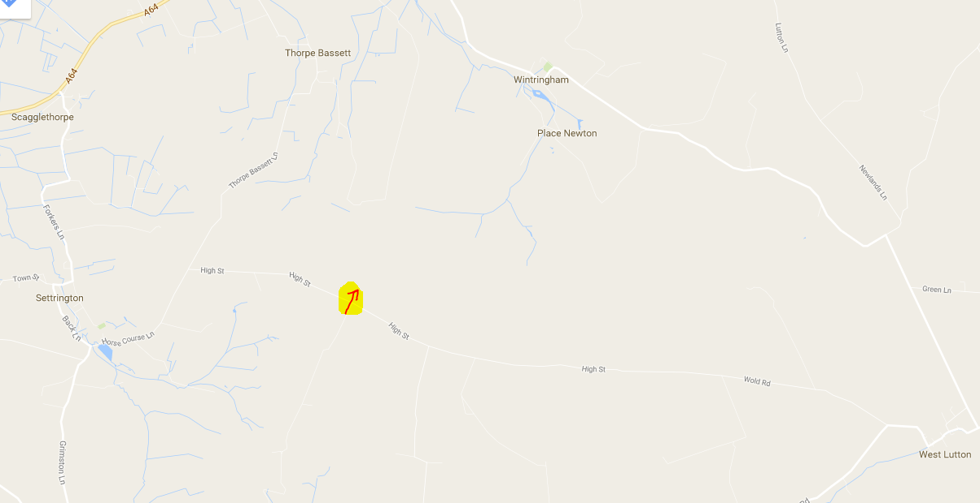

# 6. Wintringham 878 734  Postcode -YO17 8HP  8 miles (65) Cut Off 0100

**No support allowed in Wintringham**

# Checkpoint 7   Flixton Wold (road) 047 775  14 miles (79) **COMPULSORY**

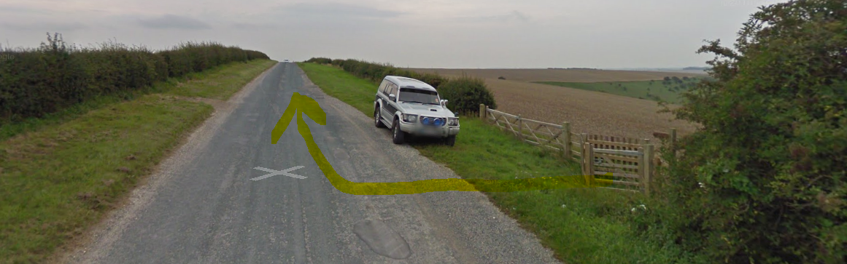

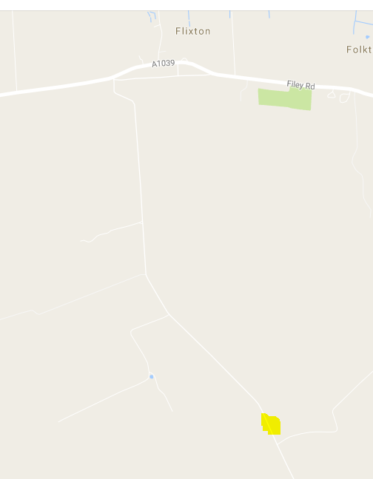

# 8. Filey Brigg (110 Start) 124 816  YO14 9ET  (88 miles) **COMPULSORY**

Start of the Cleveland way

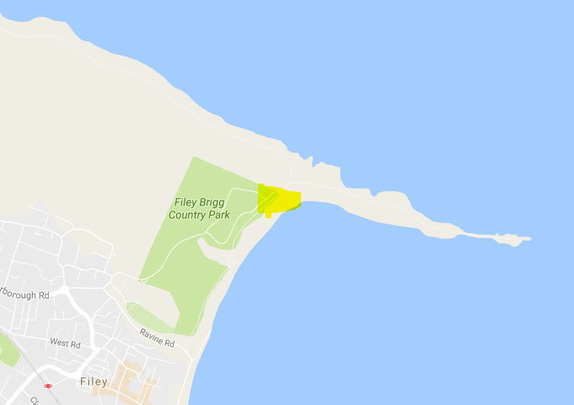

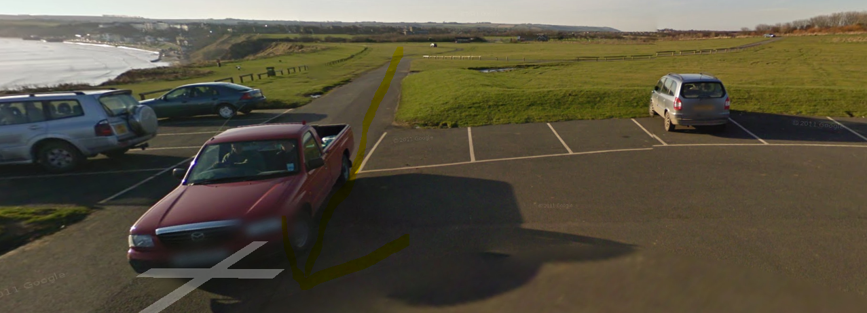

# 9. SCARBOROUGH (Holbeck Carpark) 049 867 YO11 2XD

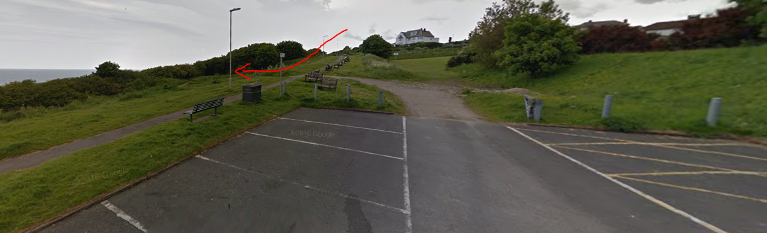

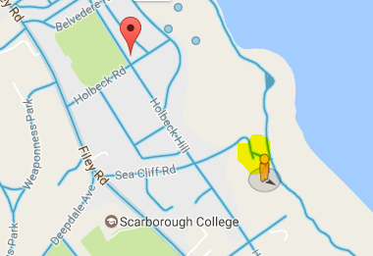

# 10. RAVENSCAR Village Hall  981 010 YO13 OLZ **COMPULSORY**

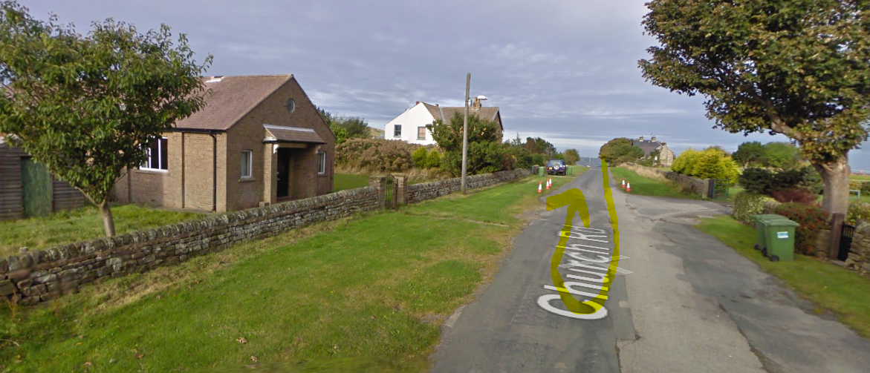

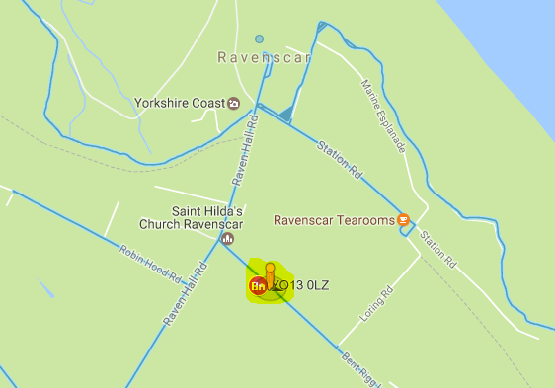

# 11. Robin Hoods Bay

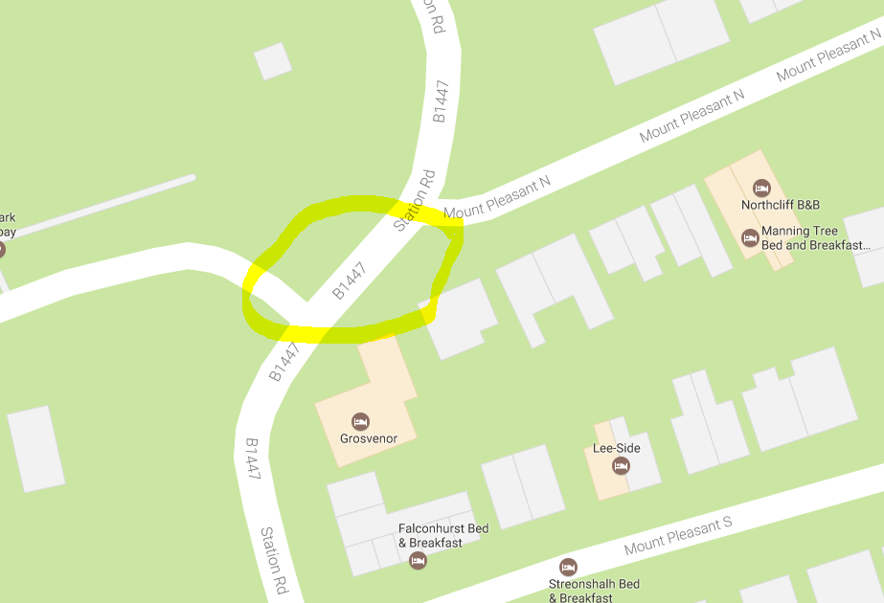

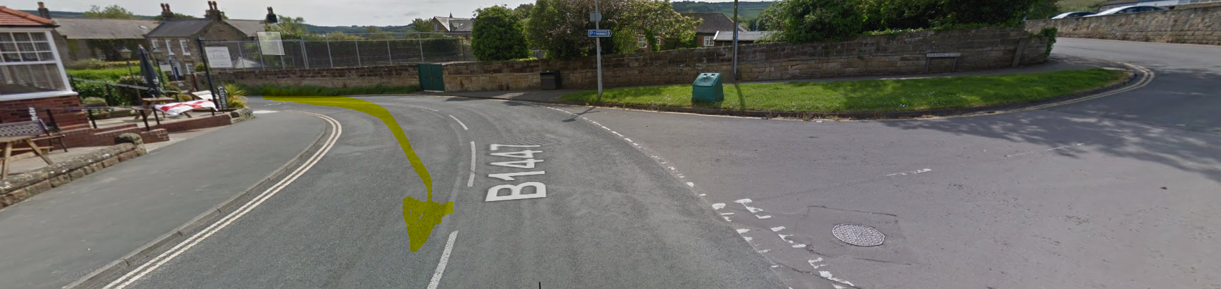

12. SANDSEND (Seafront Carpark) 860 129  YO21 3TG

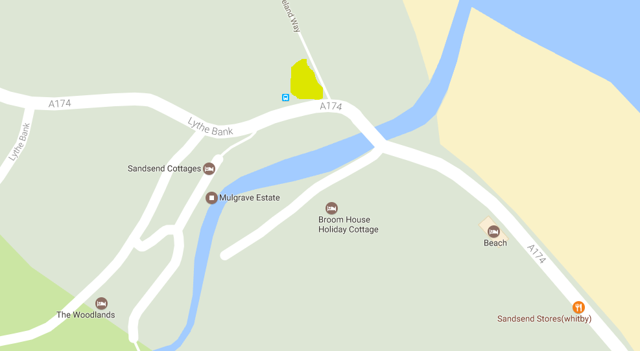

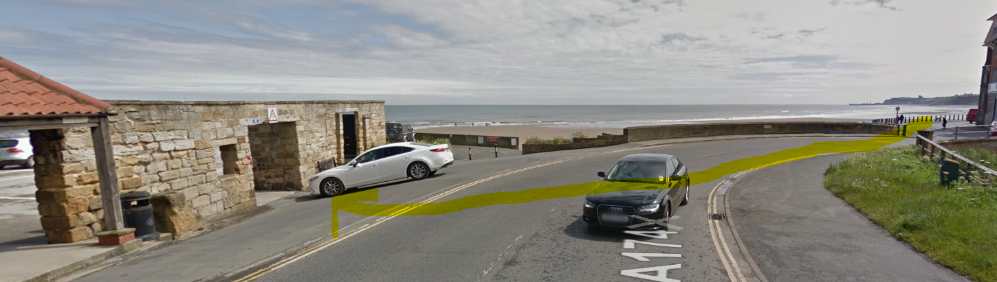

13. RUNSWICK BAY (Upper carpark) 807 161 TS13 5JF **COMPULSORY**

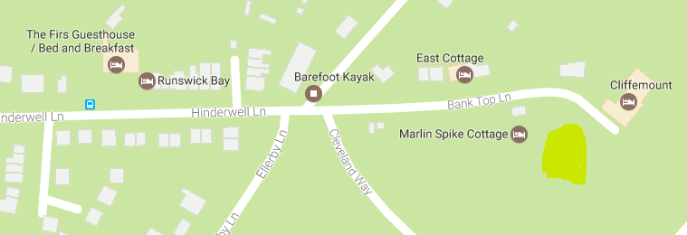

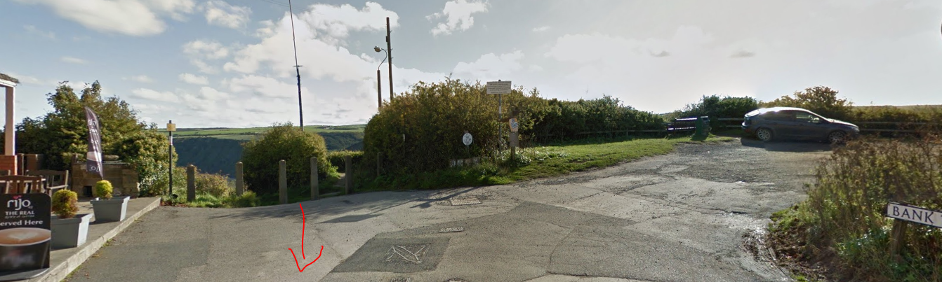

14. SALTBURN  (Seafront Carpark) 667 216  TS12 IHQ  **COMPULSORY**

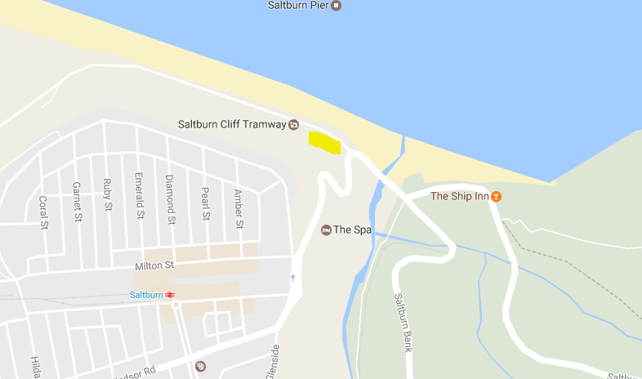

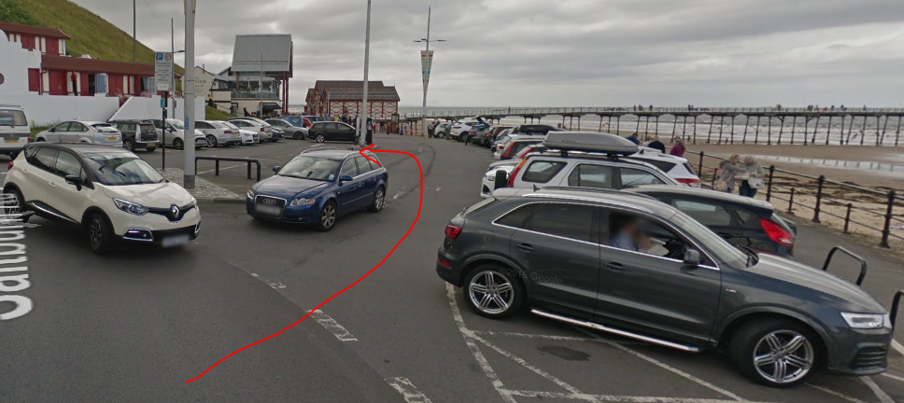

15. FOX AND HOUNDS PUB, Slapewath 643 158

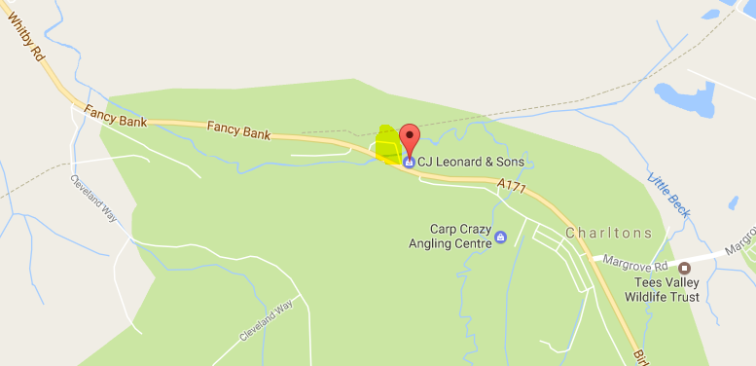

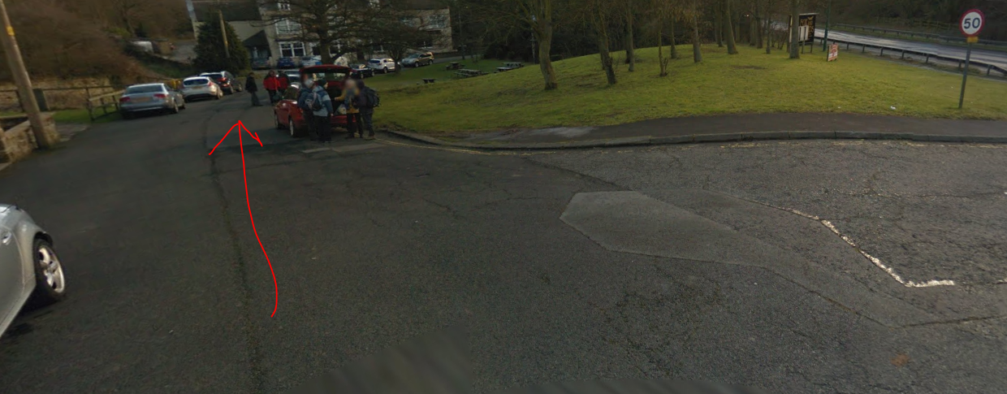

17. DIKES LANE CARPARK   592 110 TS9 6HJ (Between Captain Cooks & Gt Ayton Moor)

There is a checkpoint (16) on Roseberry Topping but support teams don’t normally go there as it’s just before Dikes Lane Carpark

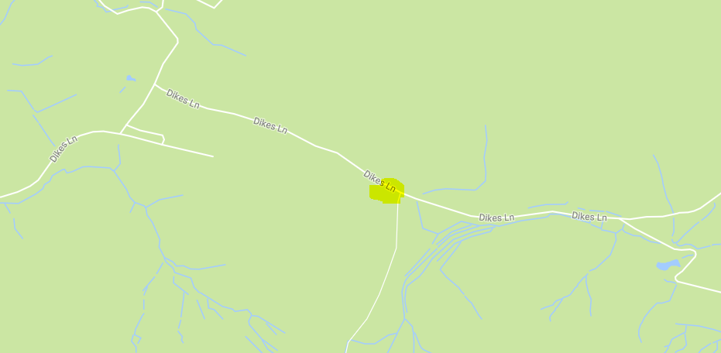

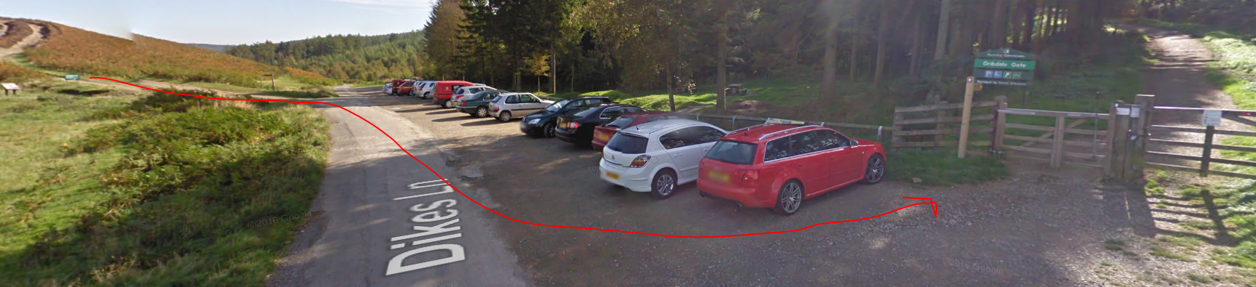

**No support allowed in Kildale**

18. CLAY BANK (B1257) 571 034  TS9 7HY  **COMPULSORY**

Take care on the road!

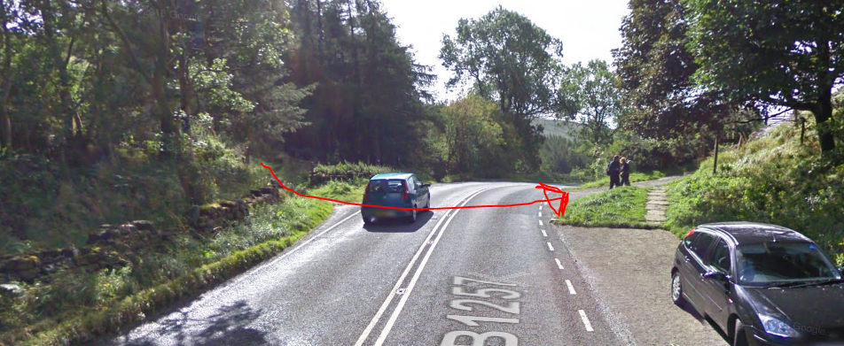

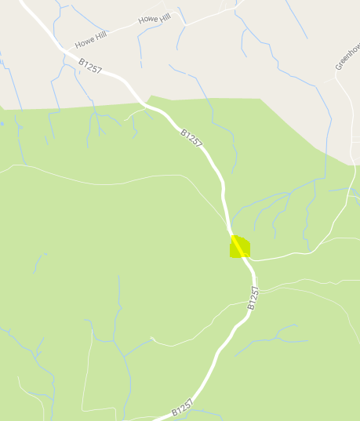

**No support allowed in Osmotherly Village**

20. SQUARE CORNER  (Osmotherley) 518 812 DL6 3QB  **COMPULSORY**

**Note – this is not in the village but on the hill to the East**

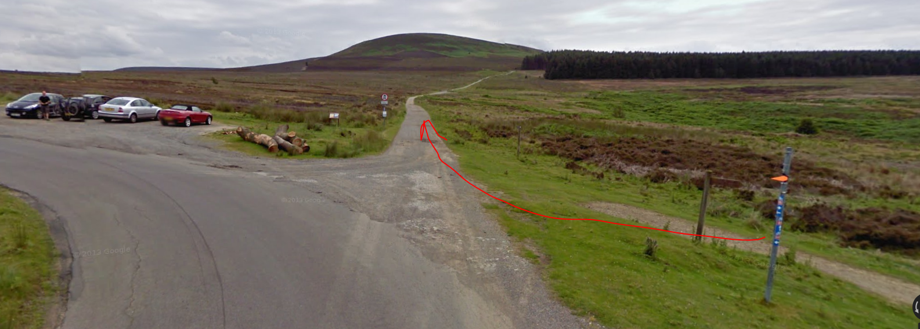

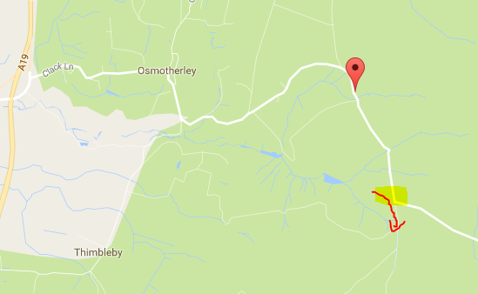

Sutton Bank Car Park (Not a check point)

Take care – busy road

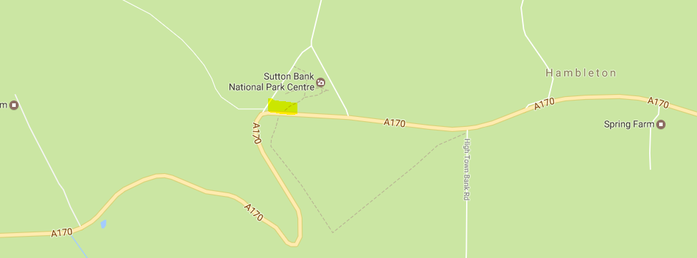

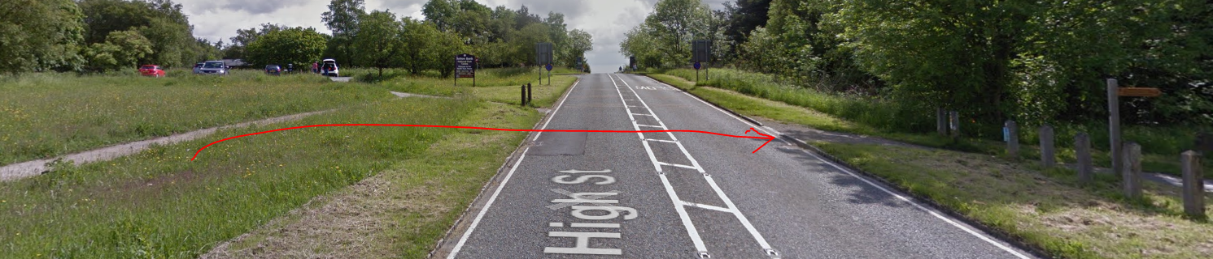

21. WHITE HORSE (Carpark) 518 812  YO61 4AN  **COMPULSORY**

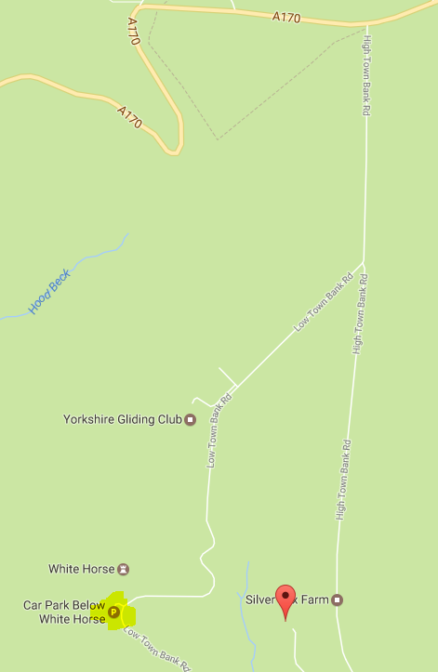

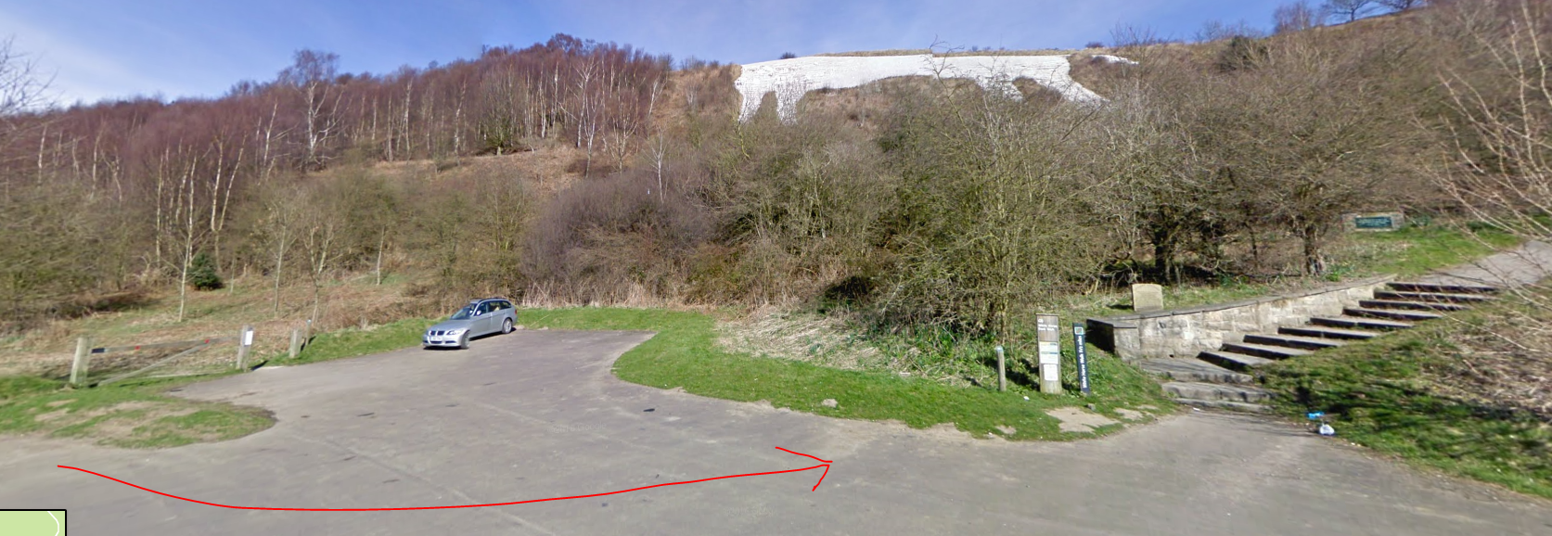

RACE FINISH Helmsley Sports Club 610 843  Postcode – YO62 5BH 10 miles (200)

